WEBSITE PLANNING & DOCUMENTATION REPORT

MMUSI DEALERSHIP WEBSITE PROJECT

- WEBSITE SPECIFICATIONS
The MMUSI Dealership website is a modern, luxury-focused automotive platform designed to showcase premium vehicles, particularly models from BMW, while providing users with an engaging and informative digital experience.

The website serves as an online showroom where customers can explore different car models, compare features, and learn about the latest automotive innovations. It highlights the dealership’s commitment to quality, performance, and luxury, aligning with the global reputation of BMW.

In addition to showcasing vehicles, the website provides essential dealership services such as:
- Vehicle information and specifications
- Pricing and availability details
- Booking inquiries and test drive requests (future feature)
- Customer support and contact options

The platform is designed with a dark luxury theme, high-quality visuals, and a user-friendly interface to attract middle to high-income individuals who are interested in premium automotive experiences.

Overall, the website acts as a digital marketing and customer engagement tool, helping MMUSI Dealership build brand awareness, attract potential buyers, and maintain a professional online presence.

Objective:
The objective of this website is to promote THE MMUSI DEALERSHIP as a luxury automotive seller by showcasing vehicles, innovation, and services while engaging potential customers.
Goals:
- Increase brand awareness of BMW vehicles sold by the MMUSI DEALERSHIP
- Provide information about car models
- Allow users to contact the company
- Collect user feedback
Target Audience:
- Demographics:
- Age: 25 – 55 years
- Gender: All
- Income Level: Middle to high-income earners
- Location: Global
Technical Aptitude:
- Familiar with online shopping and browsing
Type of Website:
- Corporate or Product showcase website
- Product Showcase
- Informational and interactive

2. INFORMATION DESIGN & TAXONOMY
SITE MAP STRUCTURE:

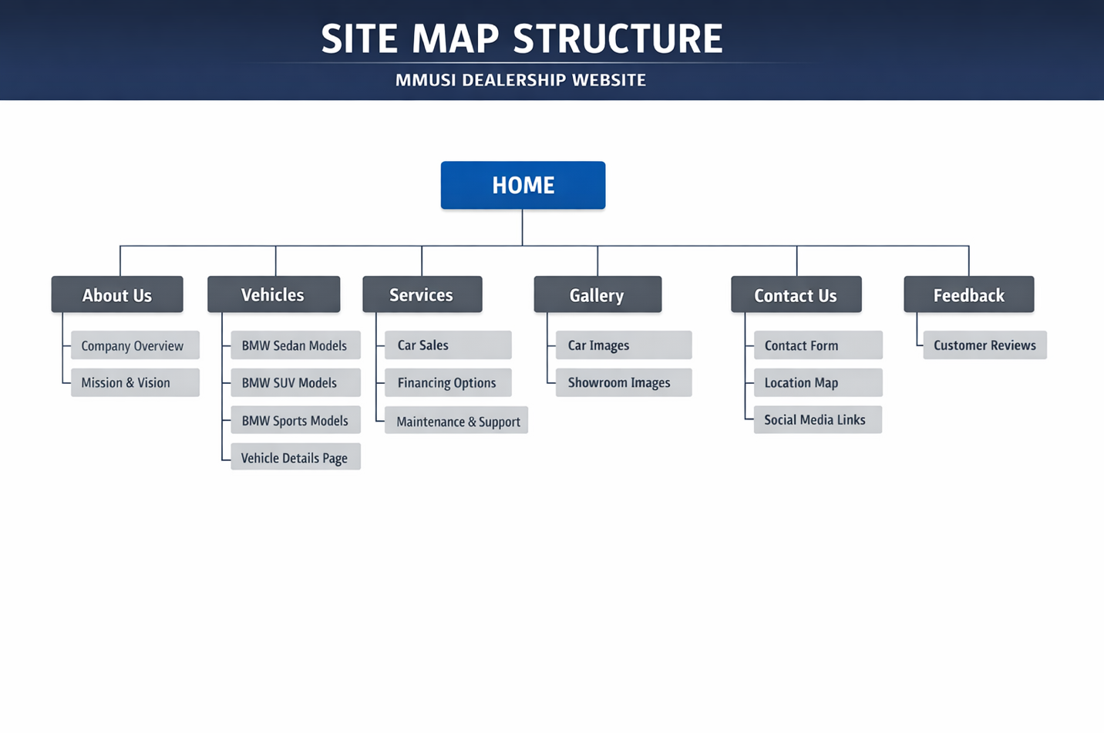

NAVIGATION FLOW:
Users can move between all pages using the navigation bar.
Max 3-click rule, ensuring easy access to all content.

3. PAGE TEMPLATE DESIGN
The website follows a consistent layout:
- Header (Navigation Bar)
- Hero Section (Image + Text)
- Content Sections
- Footer
Design Features:
- Dark luxury theme
- Large hero images
- Grid layout for models
- Clear spacing and alignment

4. TECHNICAL BRIEF
Technologies Used:
- HTML5: Used to structure the pages
- CSS3: For styling and layout
- Bootstrap: For responsive design
- JavaScript: Interactivity

Tools Used:
- VS Code: Development (coding)
- GitHub: Hosting & Version Control
- Browser Dev Tools: Testing the website
- Pinterest: Retrieval of images used for the website

5. QUALITY ASSURANCE
Testing Conducted:
- Browsers tested:
Google Chrome and Microsoft Edge
- Devices tested:
Desktop and Mobile view (responsive testing)
Results:
- Website displayed correctly across all browsers
- Responsive layout works on mobile devices

6. PUBLISHING & PROMOTION
Hosting Platform: GitHub Pages
Steps Used:
- Created repository
- Uploaded files
- Enabled GitHub Pages
Website Link Format:
THE MMUSI DEALERSHIP | Home

7. FUTURE DEVELPMENTS
- Add car booking or test drive system
- Improve accessibility features

CONCLUSION
The MMUSI DEALERSHIP website successfully meets its objectives by providing a modern, responsive, and user-friendly platform for showcasing BMW products and engaging users.

